**TECHNOLOGY ARCHITECTURE**

|  |  |
| --- | --- |
| Date | 03 NOVEMBER 2022 |
| Team ID | PNT2022TMID41426 |
| Project Name | AI-based localization and classification of skin disease with erythema |
| Maximum Marks | 4 Marks |

# Technical Architecture:

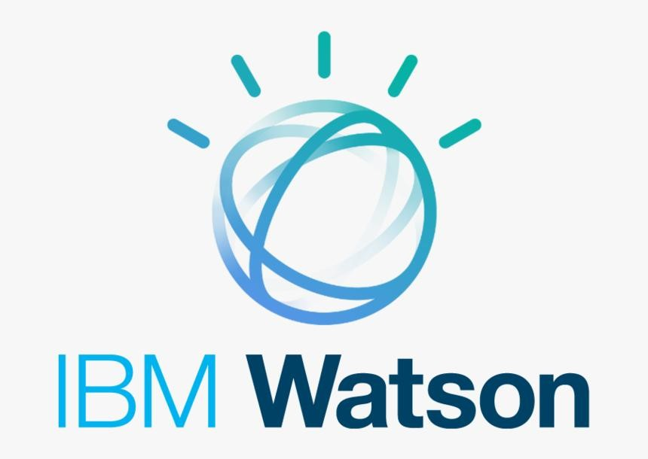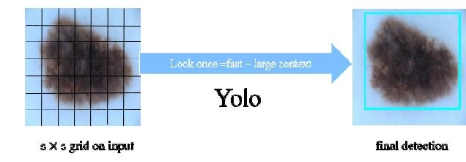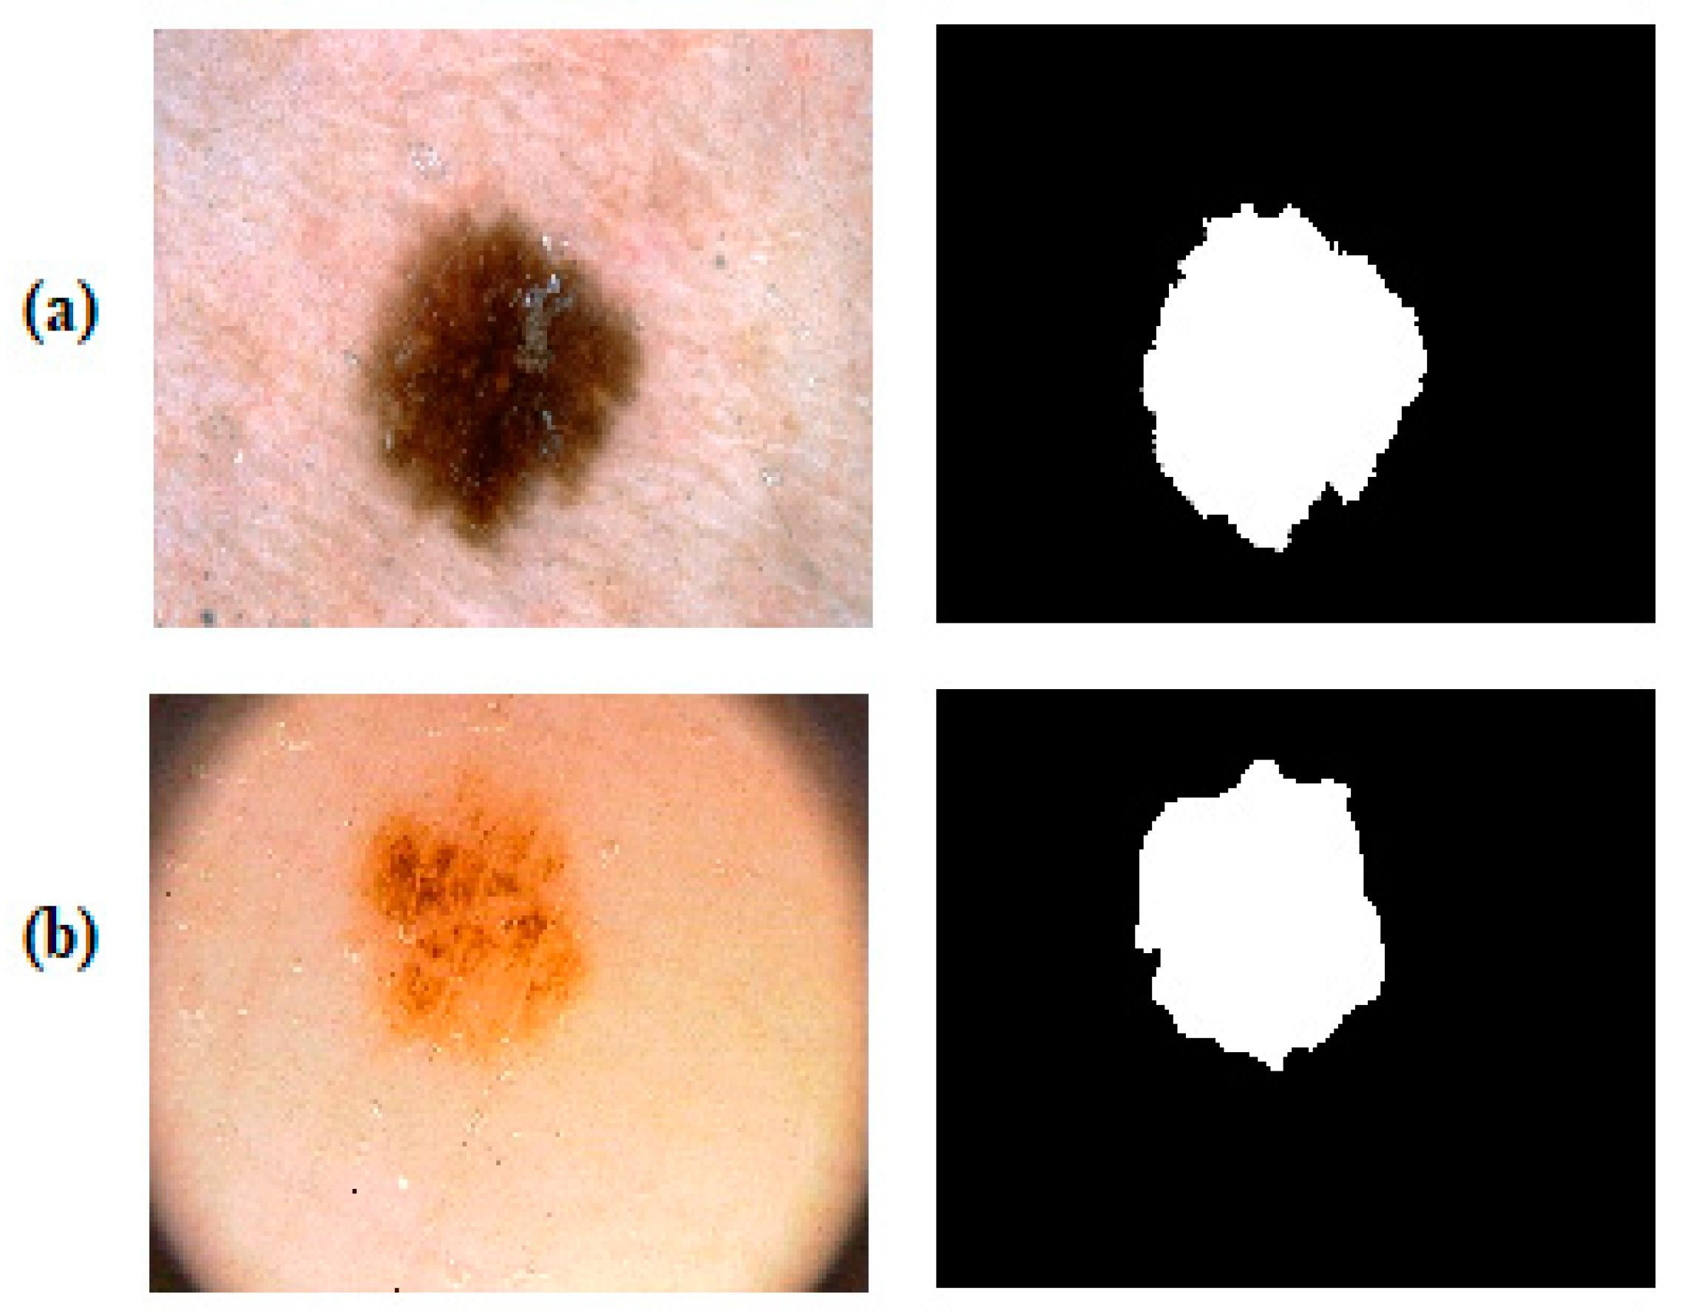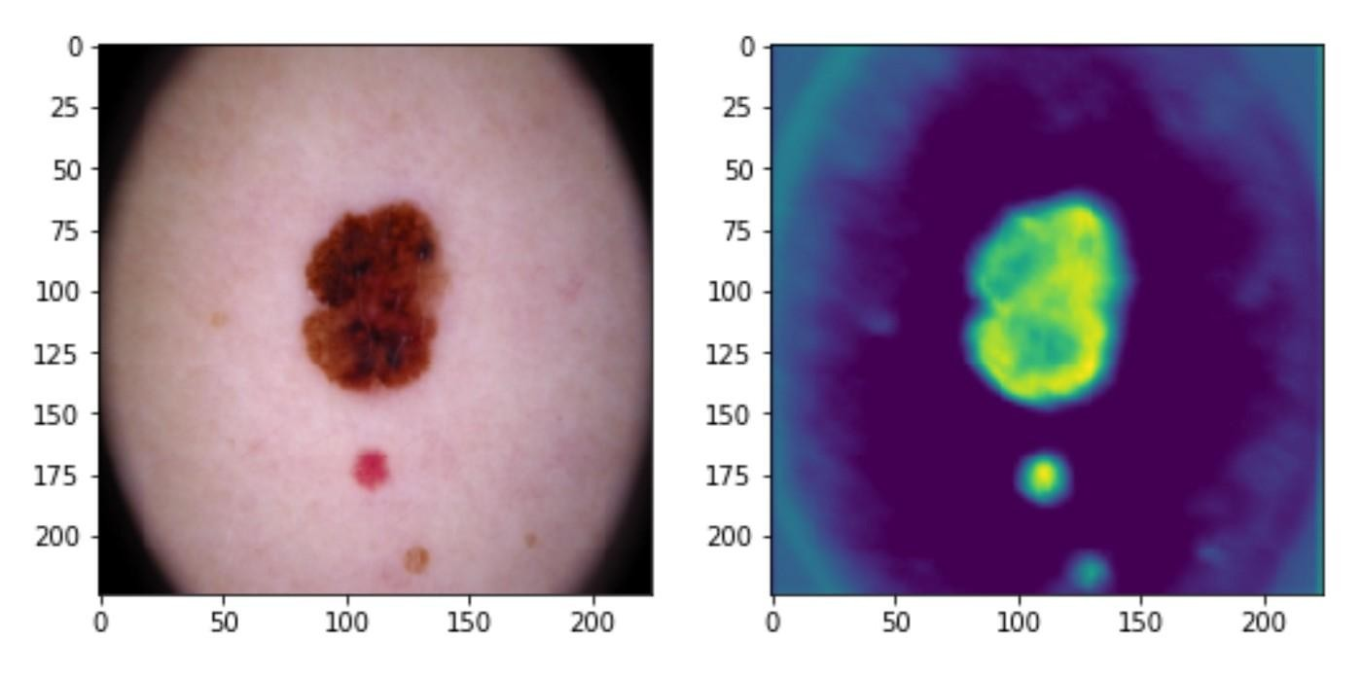

USER IBM CLOUD ADMIN

⑤

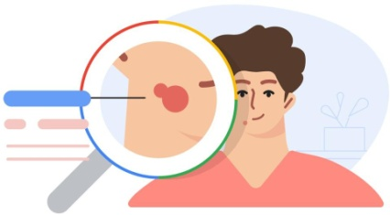④

USER LOGIN

①

PREDICTED OUTPUT



UPLOAD IMAGE

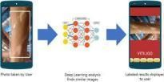

②

INPUT IMAGE

⑥

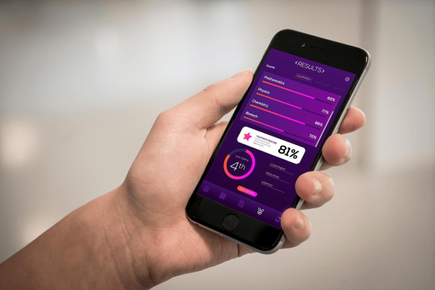

RESULT

③

# Table-1 : Components & Technologies:

|  |  |  |  |
| --- | --- | --- | --- |
| **S.NO** | **Component** | **Description** | **Technology** |
| 1 | User Interface | The user interact through the website to the application . | HTML |
| 2 | Image Processing | Image processing techniques help to build automated screening system for dermatology at an initial stage | Python |
| 3 | Disease Prediction | An image of diseased skin is given as input to the disease detection system.  Using the image prediction in done with data-set. | Python |
| 4 | Alleviate | When the disease is predicted , the suggestions are given to the user. | Python, IBM Watson Assistant |
| 5 | Database | Images of the skin disease are stored in the database | MySQL, NoSQL, etc. |
| 6 | Cloud Database | The model is deployed in the IBM cloud. | IBM DB2, IBM Cloudant etc. |
| 7 | File Storage | Images files are stored in database with the high resolution and with the type names | IBM Block Storage or Other Storage  Service or Local Filesystem |
| 8 | External API-1 | Predicted output is visible through the application | Predicted type of the skin disease |
| 9 | YOLO Model | It is used in image identification ,colour filtering and image segmentation | Image pre-processing model, Disease Prediction model |
| 10 | Infrastructure (Server / Cloud) | Application Deployment on Local System  / Cloud | IBM cloud |

**Table-2: Application Characteristics:**

|  |  |  |  |
| --- | --- | --- | --- |
| **S.no** | **Characteristics** | **Description** | **Technology** |
| **1** | Open-Source Frameworks | Google Collaboratory, Jupyter Notebook, Googledrive, Python Flask. | OpnenCV |
| **2** | Security Implementations | Assuring all data inside the system or its part will be protected against malware attacks or unauthorized access. | Encryption |
| **3** | Scalable Architecture | The website and app should be scalable. The architecture is a 3- tier model. | Python Flask, IBM cloud |
| **4** | Availability | The system will be available up to 95% of the time. | IBM cloud |
| **5** | Performance | Response Time and Net Processing Time is fast. | IBM cloud |

# References:

<https://www.nature.com/articles/s41598-021-84593-z>

[https://pubmed.ncbi.nlm.nih.gov/33674636/#:~:text=Given%20an%20image%20of%20the,information%20to%20](https://pubmed.ncbi.nlm.nih.gov/33674636/#%3A~%3Atext%3DGiven%20an%20image%20of%20the%2Cinformation%20to%20a%20classification%20model) a%20classification%20model.

[https://www.researchgate.net/publication/349833613_AI-](https://www.researchgate.net/publication/349833613_AI-based_localization_and_classification_of_skin_disease_with_erythema) based_localization_and_classification_of_skin_disease_with_erythema

<https://europepmc.org/article/med/36072725>